


Sports Performance Analytics System

MINI PROJECT REPORT

Submitted by

Harshini J 2117240030045

in partial fulfillment for the award of the
degree of
BACHELOR OF ENGINEERING IN
CSE(ARITIFICIAL INTELLIGENCE AND MACHINE LEARNING)

RAJALAKSHMI INSTITUTE OF TECHNOLOGY
KUTHAMBAKKAM, CHENNAI - 600 124
ANNA UNIVERSITY: CHENNAI 600 025

JAN/MAY- 2026
ANNA UNIVERSITY: CHENNAI - 600 025

BONAFIDE CERTIFICATE

This is to Certified that this Mini Project report “Sports Performance Analytics System ” is the Bonafide work of “Harshini J (2117240030045)”, who carried out the project work under my supervision.

SIGNATURE SIGNATURE

HEAD OF THE DEPARTMENT SUPERVISOR
Dr. N. KANAGAVALLI, Ph.D Mr. Gnana Priyan F
Assistant Professor, Assistant Professor,
CSE( AI & ML) CSE( AI & ML)
Rajalakshmi Institute of Technology, Rajalakshmi Institute of Technology,
Chennai – 600 124. Chennai – 600 124.

Submitted for the Mini Project viva-voce held on ………………..

INTERNAL EXAMINER EXTERNAL EXAMINER

INTRODUCTION
In modern sports, data analytics has become an important tool for evaluating player performance and improving team strategies. Sports like cricket generate a large amount of data for every match, including runs scored, balls faced, player contributions, and team outcomes. Analyzing such large datasets manually is difficult, time-consuming, and often inefficient, which creates the need for automated analytical systems.
This project presents a Sports Performance Analytics System that analyzes ball-by-ball cricket data to evaluate both individual and team performance. The system processes the dataset efficiently using data analysis techniques and computes important statistical measures such as mean, median, and standard deviation. These measures help in understanding overall performance, consistency, and variation among players.
In addition to statistical analysis, the system uses data visualization techniques to represent information in a clear and meaningful way. Graphs such as bar charts are used to highlight top-performing batsmen, compare team performance, and analyze bowler effectiveness. Visualization plays a key role in simplifying complex data and making the analysis easier to interpret.
The project also includes a user-friendly graphical interface developed using Tkinter. This interface allows users to interact with the system easily by selecting different options such as viewing statistics, analyzing players and teams, and generating graphs. The interactive nature of the system enhances usability and provides a better user experience.
Furthermore, the system generates useful insights by identifying the best-performing batsman, the strongest team, and the most effective bowler based on the dataset. It also provides an overall view of performance trends, such as whether the gameplay is aggressive or balanced. These insights can assist coaches, analysts, and sports enthusiasts in making better decisions.
Overall, this project demonstrates how data analytics techniques can be effectively applied in sports to transform raw data into meaningful insights. It highlights the importance of statistical analysis and visualization in improving performance evaluation, making the process more efficient, accurate, and informative.

PROBLEM STATEMENT
In modern cricket, a large amount of data is generated for every match, including ball-by-ball details of players and teams. However, extracting meaningful insights from this data is challenging when done manually, as it is time-consuming and inefficient. There is a need for a system that can process large datasets and provide accurate performance analysis in a simple and understandable way.
The main problem addressed in this project is to design and develop a system that can analyze cricket performance data and generate useful insights about players and teams. The system should compute statistical measures such as mean, median, and standard deviation, and present the results using visualizations for better interpretation.
Additionally, the system must provide an interactive interface that allows users to easily access analysis results. This helps in identifying top-performing players, evaluating team performance, and understanding overall trends effectively.

GOAL
The primary goal of this project is to develop a Sports Performance Analytics System that can effectively analyze cricket data and provide meaningful insights about player and team performance. The system aims to process ball-by-ball match data and transform it into useful information using data analytics techniques.
Another important goal is to compute key statistical measures such as mean, median, and standard deviation to evaluate performance trends and consistency among players. The project also aims to visualize the analyzed data using graphs, making it easier to understand and interpret complex information.
In addition, the system is designed to include a user-friendly graphical interface that allows users to interact with the application easily. Users should be able to view statistics, analyze players and teams, and generate visual outputs with minimal effort.
Overall, the goal is to create an efficient, interactive, and informative system that simplifies sports data analysis and supports better performance evaluation and decision-making.

THEORETICAL BACKGROUND
Sports Performance Analytics:
Sports performance analytics is a branch of data analytics that focuses on collecting, processing, and analyzing data generated during sports activities. In cricket, ball-by-ball data such as runs scored, balls faced, player actions, and team performance is recorded. This data can be used to evaluate player performance, identify patterns, and support strategic decision-making. By analyzing this data, teams and analysts can better understand strengths, weaknesses, and overall performance trends.
Performance Metrics:
Performance metrics are key indicators used to evaluate players and teams in cricket. These include total runs scored, number of balls faced, strike rate, and team total runs. For bowlers, performance can be estimated using measures such as dot balls or wicket-taking ability. Higher values in these metrics generally indicate better performance. In this project, overall performance is analyzed by combining these metrics to identify top-performing players and teams.
Data Visualization:
Data visualization is the graphical representation of data using charts and plots. It helps in simplifying complex cricket data and making it easier to understand. Common visualization techniques used in this project include bar charts to compare player performance, team scores, and bowler effectiveness. These visual tools allow users to quickly identify trends, comparisons, and performance patterns.
Tools and Technologies:
The project is implemented using Python programming language along with libraries such as Pandas, NumPy, Matplotlib, and Tkinter. Pandas is used for data processing and analysis, NumPy for statistical calculations, Matplotlib for visualization, and Tkinter for developing the graphical user interface.
Justification:
This project is justified by the growing importance of data analytics in sports. Analyzing player and team performance is essential for improving strategies and decision-making. By applying data analytics techniques, this project converts raw cricket data into meaningful insights, making performance evaluation more efficient and informative.

ALGORITHM EXPLANATION
Step 1 : Data Collection
The dataset is collected from online sources containing ball-by-ball cricket match details such as batter name, bowler name, runs scored, teams, and match information. This dataset is used as the input for analysis.
#Dataset: ball_by_ball_ipl_data.csv
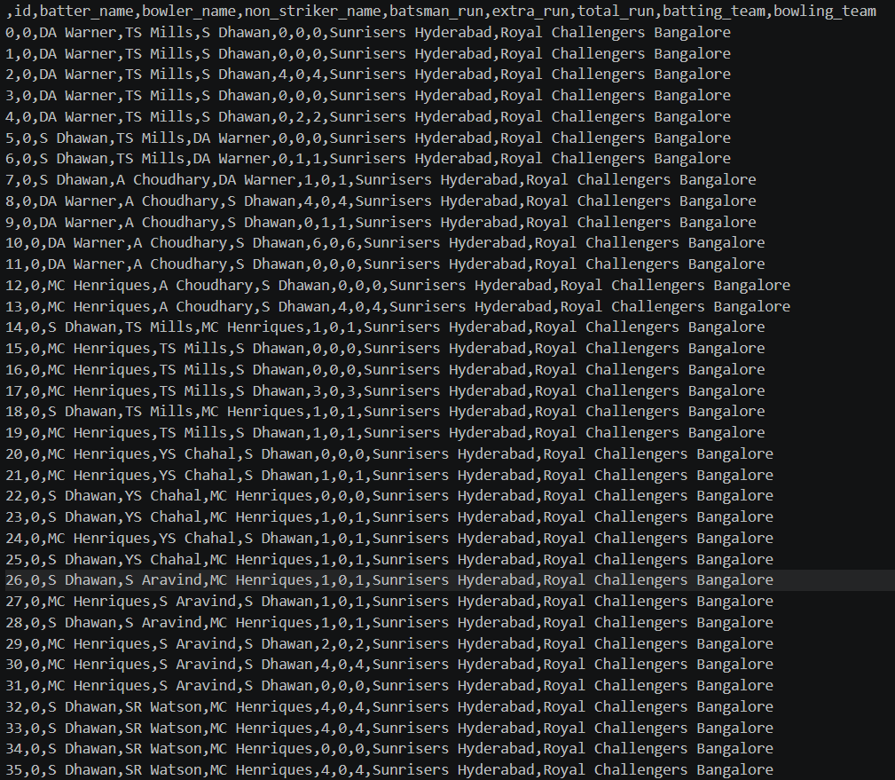

Step 2 : Data Loading
The dataset is loaded into Python using the Pandas library for further processing.
(Code: pd.read_csv("ball_by_ball_ipl_data.csv") and df.head() output table)
Step 3 : Data Preprocessing
The dataset is cleaned by removing unwanted spaces in column names and checking for missing values to ensure accuracy.
(Code: df.columns.str.strip() and df.isnull().sum())

Step 4 : Feature Engineering
New performance metrics are created such as:
- Total runs scored by each player
- Total balls faced
- Strike rate calculated using runs and balls

Step 5 : Data Analysis
The dataset is analyzed using grouping techniques to identify:
- Top batsmen based on total runs
- Team performance based on total runs
- Bowler performance using dot ball count
(Code: groupby() operations)

Step 6 : Statistical Analysis
Statistical measures such as mean, median, and standard deviation are computed to understand performance trends and consistency among players.

Step 7: Data Visualization:
Graphs such as bar charts are created to visualize:
- Top batsmen performance
- Team performance
- Bowler performance

Step 8: Result & Insights
The system generates insights such as:
- Best batsman
- Best team
- Best bowler
- Overall performance trend (aggressive or balanced)

Step 9: User Interaction Handling:
Allow users to interact with the system through GUI buttons to select different analysis options such as statistics, players, teams, bowlers, and graphs.

Step 10: Dynamic Output Update:
Update the output display area dynamically based on user selection, ensuring clear and readable results.
.
Step 11: Graph Display Execution:
Display graphical outputs in separate windows using Matplotlib for better visualization and comparison.

Step 12: System Execution:
Run the application and continuously handle user inputs until the program is closed.
root.mainloop()

Step 13: Conclusion
The analysis helps in identifying top-performing players, strong teams, and effective bowlers. It also provides clear visual and statistical insights, making performance evaluation easy and efficient.

IMPLEMENTATION AND CODE
import tkinter as tk
import pandas as pd
import matplotlib.pyplot as plt
import numpy as np
# LOAD DATA
df = pd.read_csv("ball_by_ball_ipl_data.csv")
df.columns = df.columns.str.strip()
# PLAYER ANALYSIS
player_runs = df.groupby("batter_name")["batsman_run"].sum()
player_balls = df.groupby("batter_name")["id"].count()
player_stats = pd.DataFrame({
"runs": player_runs,
"balls": player_balls
})
player_stats["strike_rate"] = (player_stats["runs"] / player_stats["balls"]) * 100
top_players = player_stats.sort_values(by="runs", ascending=False).head(10)
# TEAM ANALYSIS
team_runs = df.groupby("batting_team")["total_run"].sum()
# BOWLER ANALYSIS
bowler_wickets = df[df["batsman_run"] == 0].groupby("bowler_name")["id"].count()
top_bowlers = bowler_wickets.sort_values(ascending=False).head(10)
# FUNCTIONS
def show_statistics():
result_text.delete(1.0, tk.END)
runs = player_stats["runs"]

result_text.insert(tk.END, "📊 STATISTICAL ANALYSIS\n\n")
result_text.insert(tk.END, f"Mean Runs: {round(np.mean(runs),2)}\n")
result_text.insert(tk.END, f"Median Runs: {round(np.median(runs),2)}\n")
result_text.insert(tk.END, f"Std Deviation: {round(np.std(runs),2)}\n")

def show_players():
result_text.delete(1.0, tk.END)
result_text.insert(tk.END, "🏏 TOP BATSMEN\n\n")
for p, r in top_players.iterrows():
result_text.insert(tk.END, f"{p} | Runs: {r['runs']} | SR: {round(r['strike_rate'],2)}\n")

def show_teams():
result_text.delete(1.0, tk.END)
result_text.insert(tk.END, "🏆 TEAM RUNS\n\n")
for t, r in team_runs.sort_values(ascending=False).items():
result_text.insert(tk.END, f"{t}: {r}\n")

def show_bowlers():
result_text.delete(1.0, tk.END)
result_text.insert(tk.END, "🎯 TOP BOWLERS (Dot Ball Wickets Proxy)\n\n")
for b, w in top_bowlers.items():
result_text.insert(tk.END, f"{b}: {w}\n")

def show_insights():
best_player = top_players.index[0]
best_team = team_runs.idxmax()
best_bowler = top_bowlers.idxmax()

result_text.delete(1.0, tk.END)
result_text.insert(tk.END, "📌 SMART INSIGHTS SUMMARY\n\n")
result_text.insert(tk.END, f"🏏 Best Batsman: {best_player}\n")
result_text.insert(tk.END, f"🏆 Best Team: {best_team}\n")
result_text.insert(tk.END, f"🎯 Best Bowler: {best_bowler}\n\n")
if player_stats["strike_rate"].mean() > 120:
result_text.insert(tk.END, "🔥 Overall batting is aggressive\n")
else:
result_text.insert(tk.END, "⚖ Overall batting is balanced\n")
result_text.insert(tk.END, "\n✔ System successfully analyzes batting, bowling and team performance.")
# GRAPHS
def show_player_graph():
plt.figure()
plt.bar(top_players.index, top_players["runs"])
plt.xticks(rotation=45)
plt.title("Top Batsmen")
plt.show()

def show_team_graph():
plt.figure()
team_runs.sort_values(ascending=False).head(10).plot(kind='bar')
plt.title("Team Runs")
plt.xticks(rotation=45)
plt.show()
def show_bowler_graph():
plt.figure()
top_bowlers.head(10).plot(kind='bar')
plt.title("Top Bowlers")
plt.xticks(rotation=45)
plt.show()
# GUI DESIGN
root = tk.Tk()
root.title("Smart Cricket Analytics System")
root.geometry("1000x650")
root.configure(bg="#0f172a")
title = tk.Label(
root,
text="🏏 SMART CRICKET PERFORMANCE ANALYTICS SYSTEM",
font=("Arial", 18, "bold"),
bg="#0f172a",
fg="white"
)
title.pack(pady=10)
subtitle = tk.Label(
root,
text="Batting • Bowling • Team Analysis using Ball-by-Ball Data",
font=("Arial", 11),
bg="#0f172a",
fg="#38bdf8"
)
subtitle.pack()
frame = tk.Frame(root, bg="#0f172a")
frame.pack(pady=10)

# Buttons
tk.Button(frame, text="Statistics", width=18, command=show_statistics, bg="#f97316").grid(row=0, column=0, padx=5, pady=5)
tk.Button(frame, text="Top Batters", width=18, command=show_players, bg="#22c55e").grid(row=0, column=1, padx=5, pady=5)
tk.Button(frame, text="Teams", width=18, command=show_teams, bg="#3b82f6").grid(row=0, column=2, padx=5, pady=5)

tk.Button(frame, text="Bowlers", width=18, command=show_bowlers, bg="#a855f7").grid(row=1, column=0, padx=5, pady=5)
tk.Button(frame, text="Player Graph", width=18, command=show_player_graph, bg="#ec4899").grid(row=1, column=1, padx=5, pady=5)
tk.Button(frame, text="Team Graph", width=18, command=show_team_graph, bg="#14b8a6").grid(row=1, column=2, padx=5, pady=5)

tk.Button(frame, text="Bowler Graph", width=18, command=show_bowler_graph, bg="#f43f5e").grid(row=2, column=1, padx=5, pady=5)

tk.Button(frame, text="Insights", width=18, command=show_insights, bg="#eab308").grid(row=3, column=1, padx=5, pady=10)

# Output Box
result_text = tk.Text(root, height=18, width=110, bg="#111827", fg="white")
result_text.pack(pady=15)
root.mainloop()

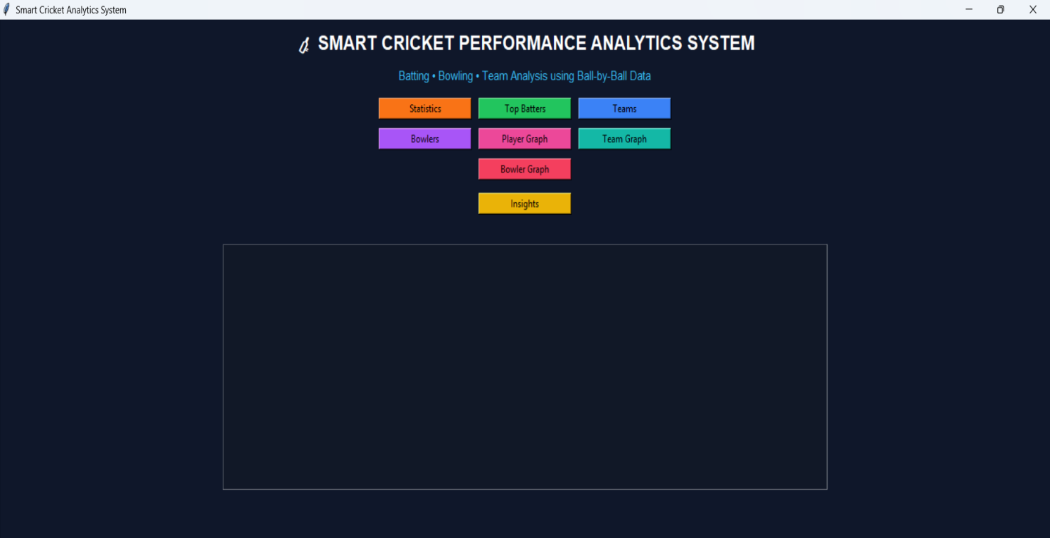
OUTPUT

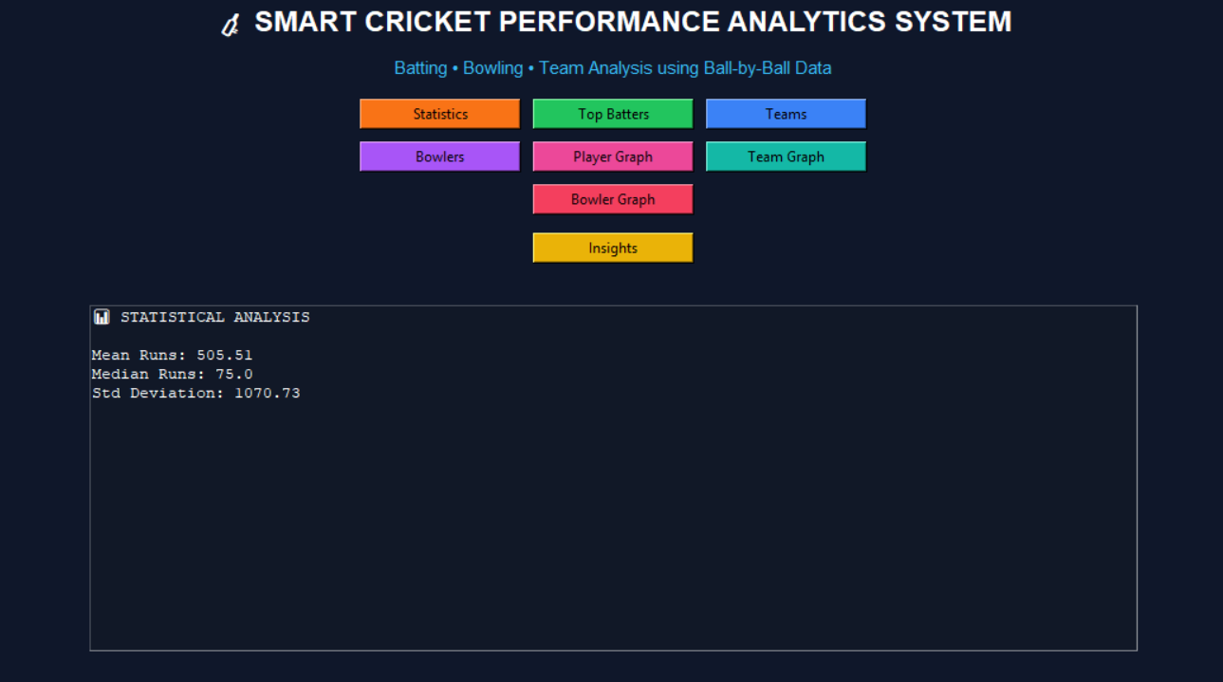

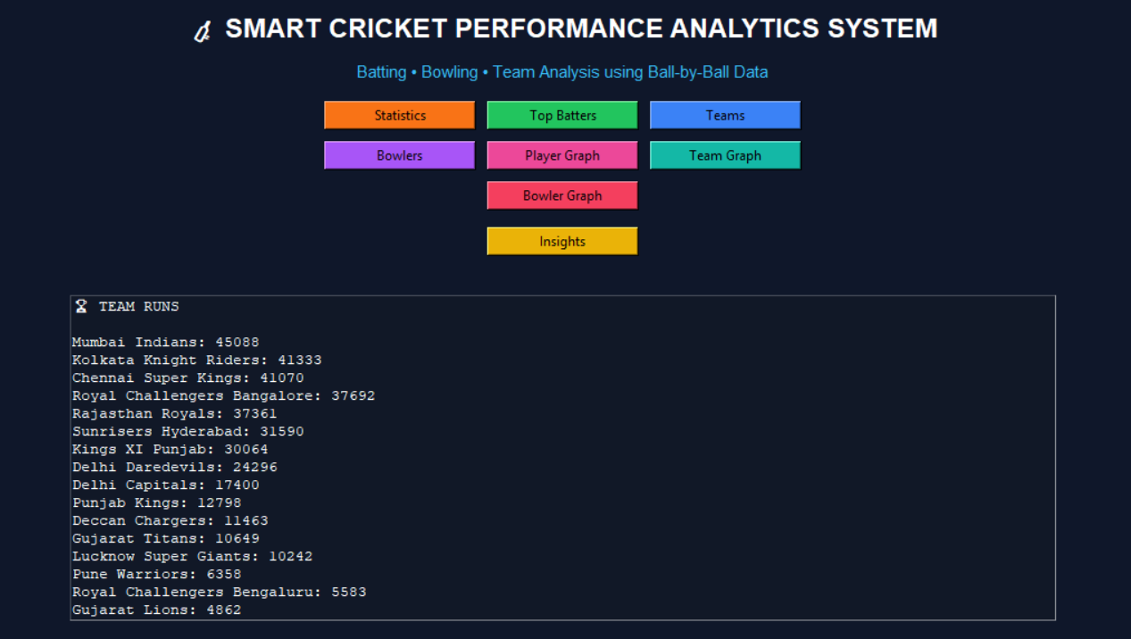
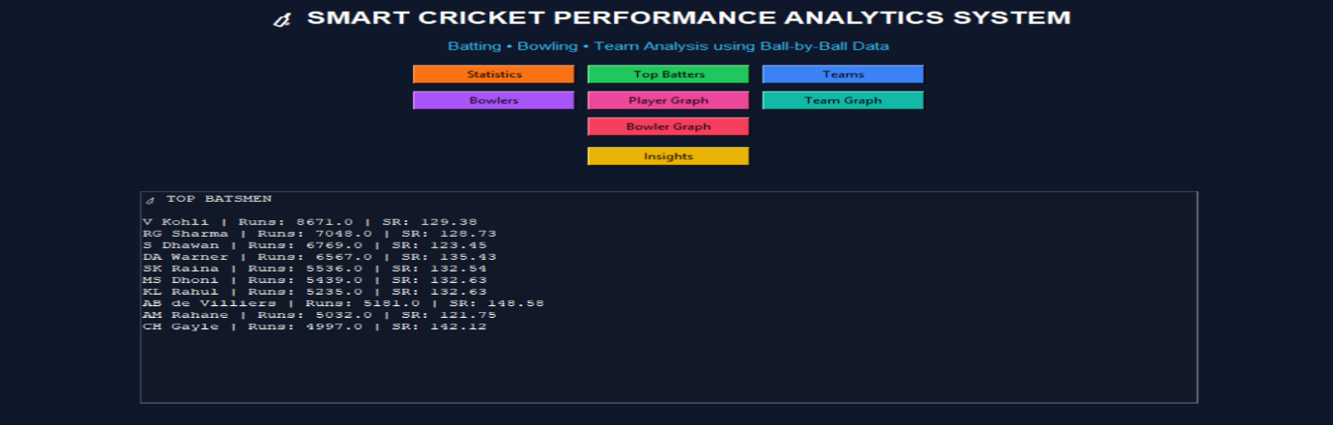

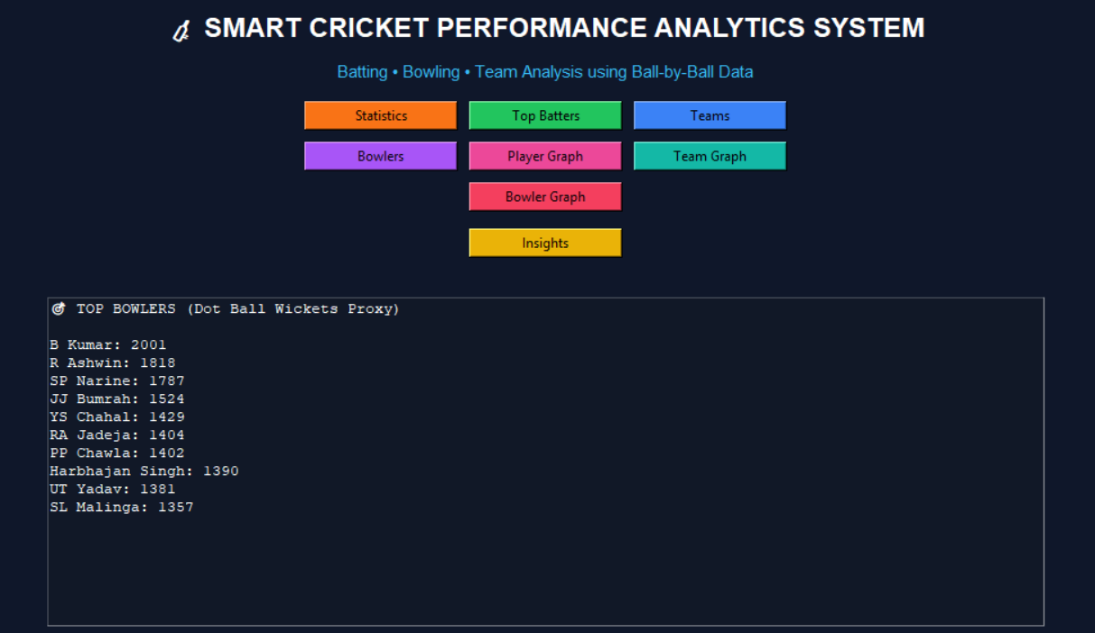
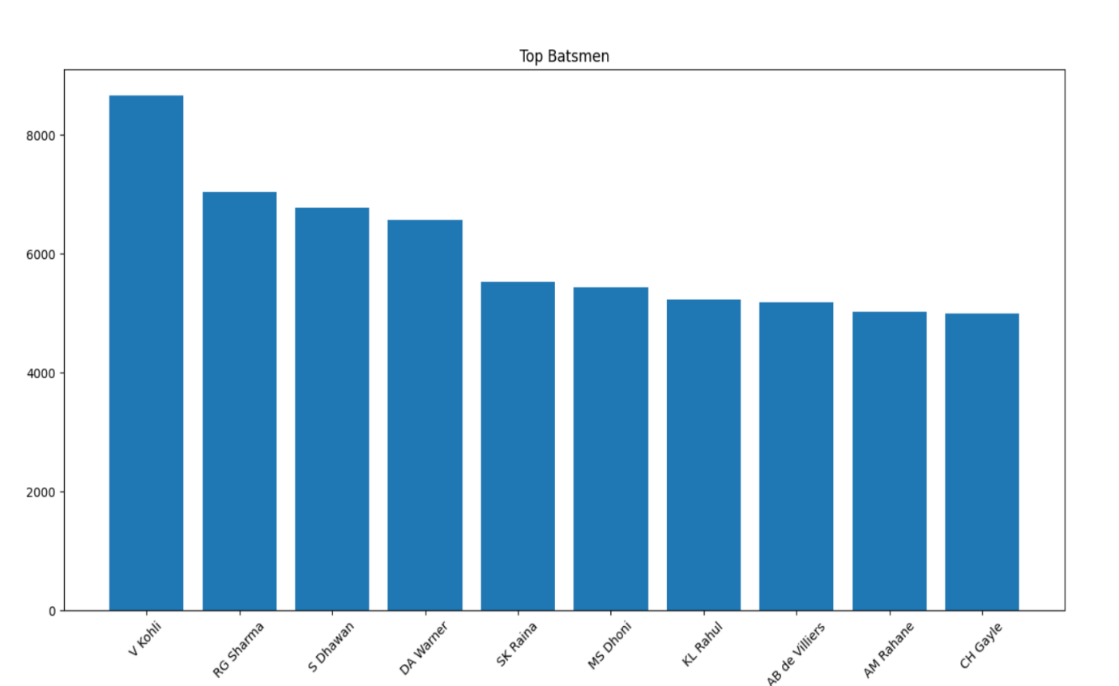

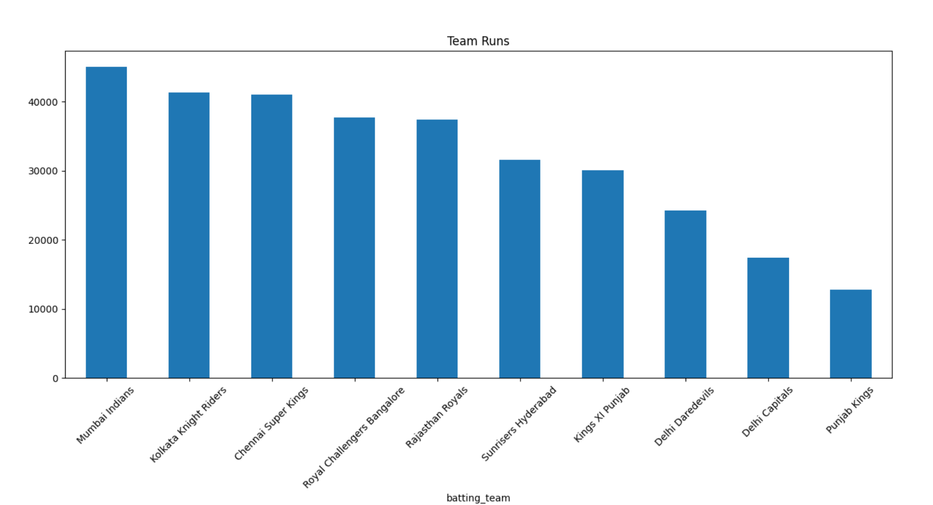

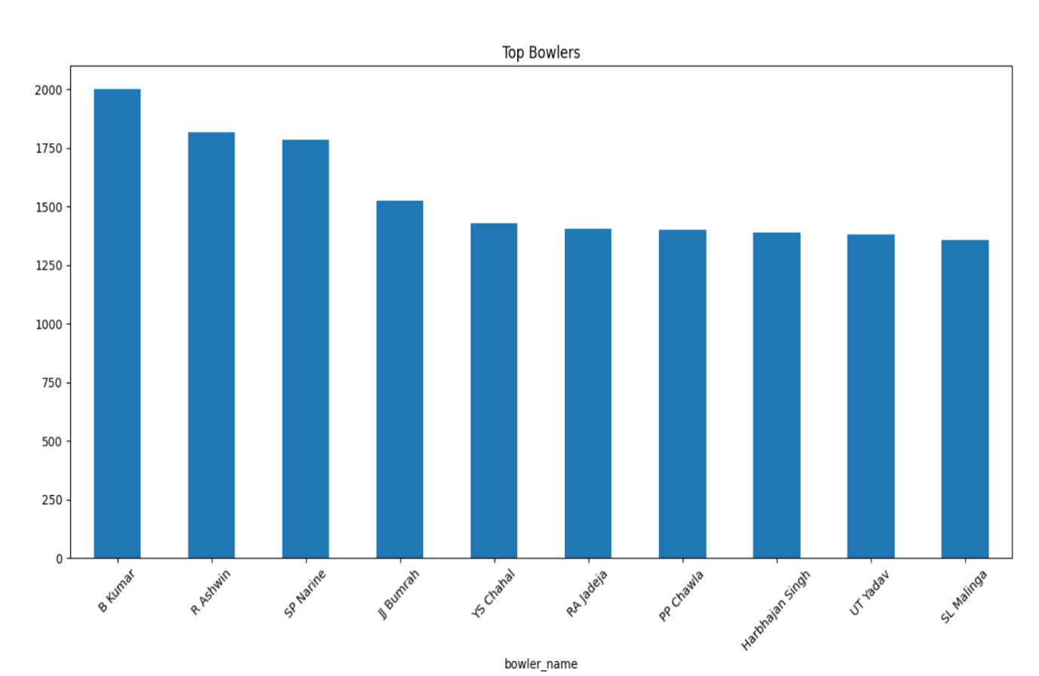

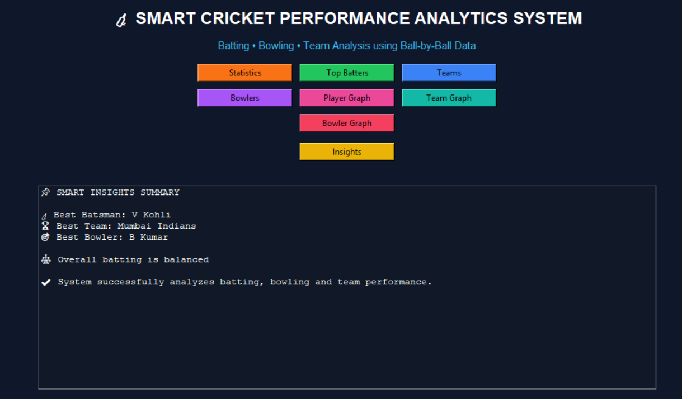
RESULTS AND FUTURE ENHANCEMENT
Results
The developed Sports Performance Analytics System successfully analyzes cricket data and provides meaningful insights about player and team performance. The system accurately computes statistical measures such as mean, median, and standard deviation, which help in understanding performance trends and consistency.
The analysis identifies top-performing batsmen based on total runs and strike rate, as well as team performance based on total runs scored. Additionally, bowler performance is evaluated using dot ball counts as an indicator. The graphical representations, such as bar charts, clearly display comparisons between players and teams, making the data easy to interpret.
The graphical user interface allows users to interact with the system efficiently by selecting different analysis options. Overall, the system produces reliable results and simplifies complex cricket data into understandable insights.
The system also helps users quickly identify key performance patterns and supports better understanding of player consistency and team strength.

Comparison With Other Approaches
Traditional sports analysis methods rely on manual calculations and basic observation, which are time-consuming and less accurate. In contrast, this system automates the analysis using data analytics techniques, providing faster and more reliable results.
Compared to basic tools that focus only on statistics, this project combines statistical analysis, data visualization, and a graphical user interface in one system. While advanced professional systems are complex and resource-intensive, this project offers a simple, cost-effective, and user-friendly solution suitable for academic purposes.

Future Enhancement
- Advanced Performance Metrics:
Include additional metrics such as batting average, bowling economy rate, and strike efficiency for more detailed analysis.
- Machine Learning Integration:
Apply machine learning algorithms to predict player performance and match outcomes based on historical data.
- Real-Time Data Analysis:
Extend the system to analyze live match data, providing real-time insights and updates.
- Web-Based Application:
Convert the system into a web application using frameworks like Flask or Streamlit for better accessibility and usability.
- Player Comparison Feature:
Add functionality to compare multiple players side-by-side based on different performance metrics.
- Interactive Visualizations:
Improve graphs by adding interactive features such as filters, zooming, and dynamic charts.
- Multi-Sport Support:
Extend the system to analyze other sports like football or basketball by adapting the dataset and performance metrics.
- Database Integration:
Store large datasets using databases like MySQL or MongoDB for better data management and faster processing.

GITHUB LINK FOR THE PROJECT AND REPORT

GitHub link for the project and report | https://github.com/HarshiniJayakumar/HARSHINI-J_DA_MINI_PROJECT

REFERENCES
- IPL Ball-by-Ball Dataset, Kaggle.
https://www.kaggle.com/
- Python Official Documentation.
https://docs.python.org/3/
- Pandas Library Documentation.
https://pandas.pydata.org/docs/
- NumPy Library Documentation.
https://numpy.org/doc/
- Matplotlib Documentation.
https://matplotlib.org/stable/contents.html
- Tkinter GUI Programming Documentation.
https://docs.python.org/3/library/tkinter.html
- Data Analytics Concepts and Techniques – TutorialsPoint.
https://www.tutorialspoint.com/data_analytics/index.htm
- Introduction to Data Visualization – GeeksforGeeks.
https://www.geeksforgeeks.org/data-visualization/
- Cricket Analytics and Statistics Overview – ESPN Cricinfo.
https://www.espncricinfo.com/
- Machine Learning Basics – Scikit-learn Documentation.
https://scikit-learn.org/stable/
- Data Science Concepts – IBM Learning Resources.
https://www.ibm.com/topics/data-science
- Python for Data Analysis – Wes McKinney

